Lighting preference profiles of users in an open office environment

Marija Despenic a,b*, Sanae Chraibi a,b, Tatiana Lashina a,b, Alexander Rosemann b

a Philips Lighting B.V., High Tech Campus 7, 5656 AE Eindhoven, The Netherlands

b Eindhoven University of Technology, Eindhoven, The Netherlands

* Corresponding author: Marija Despenic, Eindhoven University of Technology, Electrical Engineering department, Signal Processing Systems group, Flux 7.062, Groene Loper 19, PO Box 513, 5600 MB Eindhoven, The Netherlands.

Tel.: +31(0)6 48606336. E-mail addresses: [m.despenic@tue.nl](mailto:m.despenic@tue.nl)

ABSTRACT

Offices are transforming into multiuser, open space environments to stimulate interaction between people and optimize space usage. Due to design practice, lighting systems in these multiuser environments are implemented as a regular grid of luminaires that often does not match the furniture layout. Purely personal control over general lighting is in most cases unachievable. As a consequence, a single luminaire affects several neighbouring desks creating shared lighting controls and conditions. Standards provide recommendations to ensure comfortably lit offices, but do not take into account that lighting requirements between neighbouring users might differ due to their character and personal preferences. Providing satisfying lighting conditions to everyone becomes a challenge.

This paper proposes a method for modelling lighting preference profiles of users based on their control behaviour and preference information. Based on objective measurements and subjective data obtained in two field studies, users can be profiled based on their activeness with controls, dominance, lighting tolerance and lighting preference. The results show significant differences between lighting preference profiles of users.

Furthermore, this paper proposes a method for discovering and triggering submissive users to express their preferences in order to derive their profiles as accurate as possible, to secure users’ comfort by offering satisfying lighting conditions to their preference.

By knowing the lighting preference profiles of users, the probability of conflict between users can be predicted. Users’ satisfaction with lighting conditions can be automatically evaluated and enhanced.

Keywords: Light preference; user profiles; personal control; experimental study; open office; multi-user office

# Introduction

Offices in modern, commercial buildings are rapidly transforming into multiuser environments that stimulate a collaborative way of working. Closed offices are converted into open offices, low partitioned spaces, or flex environments where users do not have assigned workplaces. Furthermore, the Gensler model, envisioned to enhance user satisfaction and productivity by offering activity based workplaces is gaining in popularity [1]. Employees more often make transitions between work modes at their desk and between locations [2]. Standards provide lighting recommendations to ensure a comfortably lit office environment [3, 4], but they do not take into account that lighting requirements between neighbouring users might differ due to their mood, activity, or preference. Providing everyone with satisfying lighting conditions becomes a challenge.

## Benefits of personal lighting control

Several studies showed that lighting preferences of people differ significantly. In a windowless open-plan office with cubicle workstations, Veitch and Newsham [5] evaluated the preferred lighting conditions of 94 participants when performing office tasks. The study showed that the range of the individual lighting preferences, corresponding to the horizontal illuminance, was between 83-725 lx. In another laboratory study of Newsham and colleagues [6], participants worked in a mock-up office for one day. They had no control over lighting until the latter half of the afternoon. Participants chose desktop illuminances ranging from 116 lx up to the maximum achievable 1478 lx. In the laboratory study performed by Boyce et al. [7], in windowless offices, 18 participants were offered controllers to dim the light output of the luminaires in a large control range (12-1240 lx) or a small control range (7-680 lx). The study showed that for the same task, individuals chose different illuminance levels. The median workstation illuminance chosen ranged from 110-1230 lx for the larger and from 80-630 lx for the smaller control range. In a later performed study of Boyce et al. [8], 57 temporary offices workers spent a day in an office with the freedom to adjust the lighting of the cubicles they occupied. The study showed individual preferences to range from 252 to 1176 lx. A longitudinal field study of Moore [9] included 45 office workers in 4 different buildings in UK, where occupants were able to vary the illuminance on their workplace. The study showed that the mean daily workplace illuminance was 288 lx with individual averages ranging from 91 lx to 770 lx.

Besides the varying horizontal illuminances, the different facilities in which the experiments were conducted also resulted in varying luminance distributions. The luminance distributions are linked to the brightness perception, and will influence the preference of users. The horizontal illuminance is used as an indicator for the given dimming level of the luminaire, which creates the individually preferred luminance distribution for a given situation. Due to the shown broad range of individual lighting preferences, it is impossible to create satisfactory lighting conditions in a multiuser space by providing fixed lighting conditions to all users. With a fixed illuminance level installation, Boyce and colleagues demonstrated that the maximum amount of occupants that would be within 100 lx of their preferred illuminance is only around 65% [8]. This problem can be addressed by providing personal lighting control for office users.

Benefits of personal control are not only limited to satisfaction of individual illuminance preferences. Studies have shown that when users can adjust the illuminance level on their desks, it has a positive effect on their satisfaction with the environmental conditions [6, 10, 11, 12, 13, 14, 15, 16, 17], with lighting quantity and quality [18], mood, improved motivation and vigilance [19] and also, indirect positive effects on their productivity [6, 18, 20]. Besides, occupants that have more opportunities to adapt their environments to their own needs will less likely experience discomfort [20]. On the contrary, having a workspace without some degree of control over the environment, leads to increased discomfort and stress [21]. Therefore, personal control for office lighting is believed to enhance users’ satisfaction and comfort in modern office buildings.

## Challenges in open office environments

Due to the design practice for office lighting systems, multiuser environments are commonly deployed with a regular grid of luminaires that often does not match the furniture layout. Subsequently, it is impossible to offer desk specific lighting in most open space offices. A single luminaire would in many cases influence several neighbouring desks, thus the lighting conditions as well as lighting controls have a shared nature and are referred to as *consensus control*. The common practice in such cases is to combine luminaires into control groups such that all luminaires in one control group act as one. Multiple users get shared control over a group of luminaires affecting their desks. Analyses of 14 open-plan offices by Moore et al. showed that occupants become increasingly reluctant to make changes to the lighting as control groups become larger [22]. The researchers suggested that the control group size should be the smallest possible, while equally empowering users, to enhance user satisfaction and maximize the benefits of lighting control. The study [17] showed that even when sharing controls, the majority of users experienced the benefit of having controls and rated satisfaction with lighting quality and quantity higher than in situations without control. In a field study evaluating personal control in an open office space [23], similar results for improved lighting quality and quantity were demonstrated by the authors. However, a small portion of the users did indicate to have experienced difficulties in finding consensus with colleagues in the same control group due to opposing lighting preferences. When asked to express a preference at the end of the study, 10 out of 14 users opted for shared controls, one preferred a situation without controls, and 3 did not express a preference.

The difficulties in finding consensus might be caused by differences in individual preferences for lighting as shown in previously mentioned studies [5, 6, 7, 8, 9]. In interviews, users who participated in the performed preference study [23] indicated preferences ranging from bright light which made them feel more energized to dimmed light which was more relaxing for their eyes. A group of people indicated not to have a specific preference beyond being able to perform a visual task. Some indicated not to be critical towards a light level, and some indicated to more quickly experience discomfort glare than their colleagues. Influenced by the users’ character and sensitivity to light, a difference might exist in how picky users are in their selection of preferred lighting. User data logs of the light controls demonstrated different ranges of illuminances that users accepted without initiating a change. Some users showed a broad range of selected luminaire dimming levels, while others demonstrated more invariable choices. Similar to what was shown in the study of O’Brien [20], a conflict avoiding behaviour was observed in the authors’ study. O’Brien showed that people are profoundly affected by presence of others to take actions that might cause discomfort to colleagues. People have different personalities which can also influence how they interact with their environment in the office. Some people might be more dominant or vocal and feel less hesitation to express their preferences, while others might show a more conflict avoiding behaviour.

## Research motivation

Personal characteristics are believed to have an influence on users’ preferred and selected lighting, when given a choice. This paper presents insights gained from analysing light preference data of the users, obtained in two field studies. We show that users can be profiled based on their light preference and control behaviour in the following ways:

* *Activeness* – The level of activity of each user can be determined based on the number of user control actions. The user’s control actions are a good basis to derive the user’s preference profile. Having only a few control actions of a user, makes derivation of user’s profile difficult.
* *Tolerance* – A tolerant user will select a broad range of illuminances meaning that he can work under a larger variety of lighting conditions. Contrarily, an intolerant user will demonstrate a more consistent preference for illuminance levels. When weighing users’ light preference profiles to offer satisfying lighting to multiple users, the tolerance of the users should be taken into account. The preference of an intolerant user asks for a higher weight, meaning that the proposed illuminance level should be shifted towards the light preference profile of the intolerant user. Users with a broad tolerance range will less likely experience conflict.
* *Dominance* – Dominance is observed via the correlation between a particular user preferred illuminance level and the prevailing luminaire output in that zone. The dominance of a user is determined as a fraction of time the luminaire output matched the illuminance level set by that user. If the output of the luminaire is set according to the user’s preference for most of the time, the user is dominant in that control zone. Submissive (non-dominant) users are intimidated by others and manifest conflict avoiding behaviour, resulting in not changing the illuminance level even when dissatisfied.
* *Preference –* The preference of a user is the control setting that is most comfortable for that user, leading to the highest user’s satisfaction with lighting conditions. Having opposing lighting preferences in one control zone might introduce dissatisfaction of the users and pose a risk of conflict.

Control zones can be classified based on lighting preference profiles of the users who occupy them, and the zone luminaire output. By knowing the classification of control zones, users’ satisfaction with lighting conditions can be automatically evaluated and enhanced. Besides, possible conflict between users in a same control zone can be predicted and the process of making consensus choices can be facilitated, to improve user satisfaction.

This paper proposes a method for modelling lighting preference profiles of users and classification of control zones based on user control behaviour to offer satisfying lighting to a group of users. This paper will present the cases where additional feedback from the users will be required to secure or enhance users’ comfort by offering lighting satisfying to their preference.

# Methodology

Data obtained from two field studies conducted in an open plan office in 2013 (*study 1*) and 2014 (*study 2*) was used to explore different lighting preference profiles of users. The focus of the studies was to evaluate whether benefits of personal control would still be observed when applied as consensus control in an open office environment. For the purpose of the studies, the test-bed installation was set up in an office building in the Netherlands. Both studies were conducted as field studies in order to explore and validate user benefits of using lighting controls in a realistic setting. A longitudinal design allowed social dynamics to evolve during the course of the studies. The following sections provide essential details of the test-bed implementation and study design of the two conducted studies.

## Test bed

Figure 1 shows a schematic representation of the office where the test-bed was located. As in most open office spaces, due to the office layout and the predefined grid of luminaires, it was impossible to offer truly personal control over a luminaire to each user. In order to give the participants an equal sense of control, luminaires were combined into control zones, such that one control zone would be offered to the smallest possible number of users as suggested in [22]. This resulted in combining two luminaires per zone, shown as green rectangles in Figure 1, leading to a total of 6 control zones with 2-3 users per zone. This way, the control of lighting is not personal, but labelled as consensus control.

To implement the test-bed, an existing lighting installation with 16 TL5 49W lamps, was modified in accordance with the study requirements. All 16 lamps were equipped with DALI high frequency dimmable ballasts Philips TD 1 28/35/49/54 TL5 E+ to allow dimming of the luminaires in the 6 control zones. The 12 central luminaires were controllable by user interfaces. The outer 4 luminaires adjacent to the walls were held at a fixed light output to maintain sufficient and uniform wall luminance. This was done to avoid sharp contrasts on the walls that could result from daylight entering the office, since sharp contrasts were shown to negatively influence the overall space appraisal [24]. Combined light and occupancy sensors Philips PLOS-CM-KNX were mounted on the ceiling next to each of the 12 central luminaires. The lighting in the entire space was switched based on occupancy controls. When the first person entered the office, all lights turned on; after the last person left the office, all lights turned off after a timeout of 30 minutes.

In both studies participants were offered personal user interfaces to control the lighting of their zone. The personal user interfaces are further explained in Section 2.2.

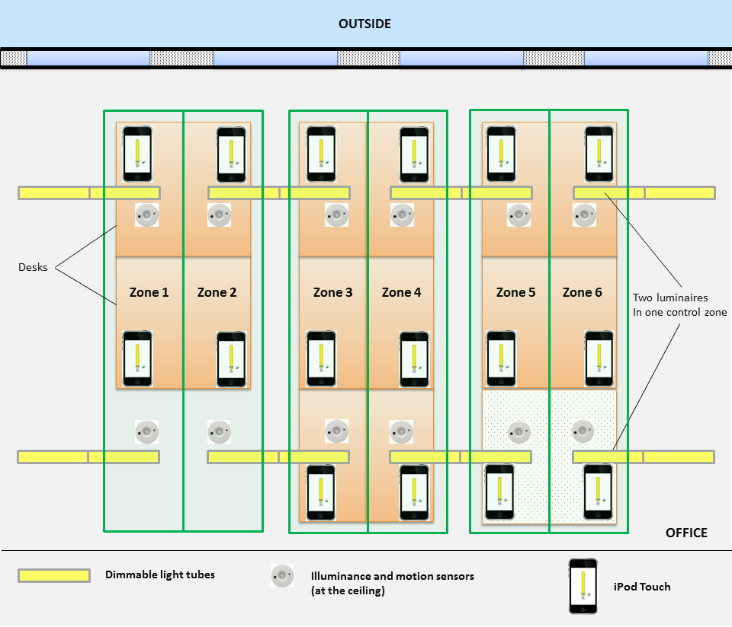

Figure 1. Schematic representation of the test-bed in the open plan office. Green rectangles represent the different control zones with two luminaires in each zone. In *study 2*, two additional desks were placed in the office space visualized in the bottom right corner.

## Study design

The analysis is based on data of the study conditions in which the participants were offered lighting controls. These conditions were commissioned with “memorizing” system behaviour. The default dimming level of the 12 controllable luminaires was set to 60%. This created an average desk illuminance of 300 lx by artificial lighting with the ability to be changed, by each participant, in a range from full luminaire output (average desk illuminance of 500 lx) to completely off. Escuyer [25] showed that in presence of daylight, users who worked behind computer screens preferred illuminance levels between 100 and 300 lx. Moore's study [22] showed that the higher the percentage of time office users spent behind a computer screen, the lower the selected desk illuminance was recorded, being on average 300 lx. The results of a study performed by Reinhart and Voss [26] showed that switch on probability of lights decreased below 0.1 when 300 lx was offered to the users. In accordance to these findings and provided that the participants spent most of their time on screen based tasks, the default level of 300 lx desk illuminance was chosen. The luminaires within every control group stayed at the previously set dimming level until the next control action was performed. The dimming level could be overwritten by every user in a zone, at any point in time. After a change was made, the user interface was updated to present the current dimming level of the control group. At the end of each day, the last user selected dimming level was memorized by the system and restored in the zone upon detection of presence the next day.

Besides the “memorizing” user-control condition, *study 1* also included a reference condition, in which the participants did not have lighting control. In *study 2*, besides the reference and “memorizing” control condition, additional conditions were offered to the participants. Only the user-control conditions with the same system behaviour were used for the preference profile analyses, as shown on the study timelines in Figure 2.

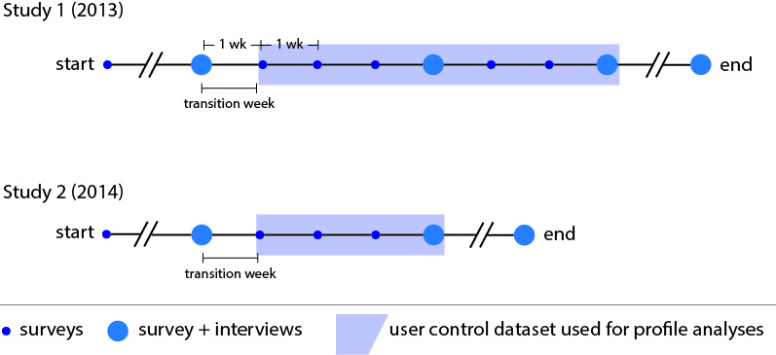

Figure 2. Timeline of *study 1* and *2* with used datasets marked.

In *study 1* each participant had a widget installed on their PC as well as an iPod Touch device on their desk, both running a light control application (Figure 3a). The application visualized a slider to control zone lighting from 1% to 100% of the maximal luminaire output, and a button to turn lights off. In *study 2* participants received an iPod Touch device with a comparable light control application, to control zone lighting from 1% to 100% of the maximal luminaire output (Figure 3b). Incorporating the usability feedback of *study 1*, the user interface was updates for *study 2*, leaving out the “off” button.

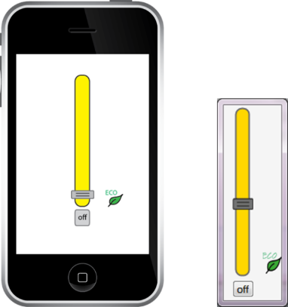 (a) 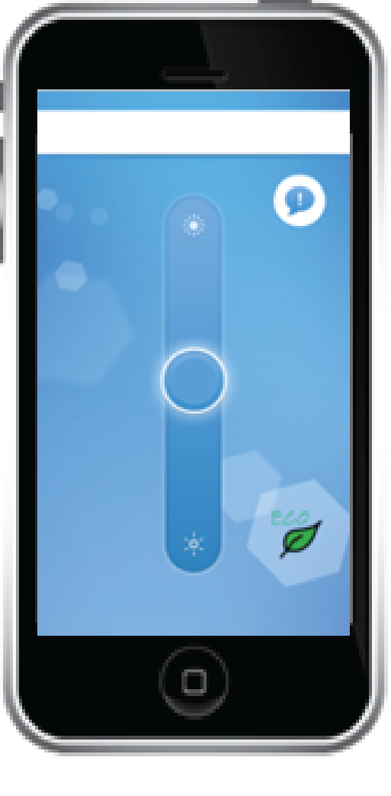(b)

Figure 3. Light control application of *study 1* on an iPod Touch and a widget (a), and of *study 2* on an iPod Touch (b).

## Measurements

The objective measures consisted of data logging from the luminaires and the user interfaces. During both studies log files were created of the light output of the luminaires (logged every 1 minute). These are translated into relative light output logs, where 100% represents an average desk illuminance of 500 lx. The relative light output of the luminaire will be further referred to as the dimming level. Log files of the user actions consisted of the user-selected dimming level, ranging from 0-100% in *study 1* and 1-100% in *study 2*. The first week of user-control, labelled as ‘transition week’ in Figure 2, has been excluded from the analyses due to a novelty effect. During the ‘transition week’ users experimented with controls much more, resulting in a deviation in the behaviour with the controls compared to the rest of the user-control condition. Users’ actions were initiated by the users themselves, thus no predefined logging rate existed, and actions were logged at the moment they took place. Since users often performed several actions per minute while trying to find the appropriate lighting conditions, actions within a time window of 5 minutes were filtered out. The assumption is made that only the last, user action represents the preferred illuminance. Only these last actions are included as meaningful data points for further processing.

The subjective data used for the analyses described in this paper has been collected via online surveys and interviews. During the entire length of both field studies, users filled in surveys on a weekly basis. Survey questions were presented in English with a Dutch translation underneath each item. In the survey the perceived light quantity and the frequency and degree of conflict due to the use of the shared lighting controls were adopted from [27]. The participants were asked to evaluate the light quantity on their desk from the artificial lighting on a 7-point scale, ranging from ‘*too little*’ to ‘*too much*’ [17]. Besides using the scale to analyse whether lighting was experienced as brighter or darker than they preferred, the assessment of light quantity is recoded into 4 rather than 7 steps, allowing for an overall assessment of dissatisfaction with the quantity of light. Here the extremes of *‘too little’* and *‘too much’* are translated into ‘*very dissatisfied’*, the *‘just right,’* middle point into *‘satisfied’*, and the steps in between into *‘somewhat dissatisfied’* and *‘dissatisfied’*. At the end of each experimental period, after 3 or 4 weeks (see Figure 2), an interview between each participant and one of the researchers allowed to further elaborate on what was captured in the surveys. Interviews delivered complementary qualitative information used to understand the data and the obtained results. In the interviews participants were implicitly asked to describe their lighting preference relative to their colleagues. Subjective data collected in the interviews is found relevant to the preference profiles, and is included in this publication. Other parameters of the interviews and surveys are published separately [23].

## Participants

In *study 1* a group of 14 administrative workers was relocated to the test-bed for the study duration. The participants were offered fixed workplaces in the open plan office with 14 desks (Figure 1). The participants (30 – 65 years, 3 females and 11 males) worked on their actual job tasks while experiencing the study conditions. They were naïve regarding lighting knowledge, and they were at the same corporate hierarchical level. All participants were Dutch speaking (as a first or second language) and had good English reading and speaking skills, therefore they had no linguistic barriers for interaction.

Due to relocation of organizational departments, in *study 2* a second group of office workers was allocated to the test-bed that had 16 workplaces (Figure 1) at the time of *study 2*. 14 subjects participated in the study, all had a fixed desk position. The remaining 2 desks, located in zone 4, were used by employees with limited presence. These users did not participate in surveys or interviews, but were provided with a device for light control. Prior to the study most group members did not share an office together or have worked in an open office. The group included participants ranging from students to senior employees, but none of the participants had their organizational superior in the subject group, in order to rule out possible conflict avoiding behaviour arising from such a situation. Similar to *study 1,* the participants in *study 2* (25 – 65 years, 1 female and 13 males) maintained their working habits and conducted their office tasks as usual while experiencing the study conditions. The participants had no lighting or perception domain knowledge. 13 participants were Dutch speaking (as a first or second language). All participants had good English reading and speaking skills.

In both studies, the study design and objective were not shared with the participants beforehand. They were informed to be part of an evaluation regarding their experience in the open office, and would receive study details afterwards, to avoid subject bias. Participants were briefed about the lighting control option at the moment they received the user interface. Prior to the user-control condition, participants experienced a reference study condition without user control over lighting. During a baseline period of 4 weeks, the participants (n=28) could get used to the office and their neighbouring colleagues, before the lighting control was introduced. Prior to the study, the participants were only acquainted with the control possibilities of the external blinds.

## Clustering

The number of classes for tolerance and preference are unknown. Therefore classification of users regarding these features is done by unsupervised learning. The task of unsupervised learning is to infer classes by properly describing a hidden structure of unlabelled data. For this task, the *K-means clustering* algorithm is used [28].

Suppose a given data set consisting of *N* observations that are *D*-dimensional. The *K*-means algorithm will partition the data into *K* number of clusters such that their inter-point distances within a cluster are small compared to distances to points outside the cluster. The , where , are *D-*dimensional vectors representing the centres of the clusters. The goal is to find an assignment of each data point to clusters, as well as a set of vectors , such that the sum of squares of the distances of each data point to its closest vector is minimal. The formal mathematical representation of the *K-*means algorithm is given in [29].

To validate and interpret the consistency within each cluster of data, the *silhouette* criterion, introduced by Rousseeuw [30] is used. A silhouette is a measure representing how similar a data point is to its own cluster compared to other clusters. The main advantage of the silhouette criterion is that it does not assume that class labels are available, since, in this analysis, labels of users regarding tolerance and preference are unknown a priori. A silhouette value of the point is given as

(1)

where is the average distance from the point to the other points in the same cluster as , while is the minimum average distance from the point to points in a different cluster, minimized over clusters. The silhouette value ranges from -1 to 1, where high values indicate that a data point is matched well with its own cluster and poorly to neighbouring clusters. If most of the data points have high silhouette values, the clustering is appropriate. If most points show low or negative silhouette values, the clustering configuration either has too few or too many clusters. Values around zero indicate overlapping clusters.

The clustering is repeated 100 times to reduce estimation variability. The centre of each cluster is estimated by performing a majority vote over 100 iterations. The average distance between these centres is used to discriminate the users between the clusters.

# Results

In this section, results obtained in the two studies are presented. Users are classified based on their personal control behaviour. Classification of control zones is based on the user profiles, and the luminaire output data of that zone. It takes quantitative data into consideration and compares it with the results obtained through surveys and interviews with the participants in the studies.

## Activeness

Each individual user’s level of activity can be determined based on the number of user control actions. A user is assumed to be active if he provides enough inputs such that his profile can be derived. An inactive user will show a lower frequency of control actions, which makes derivation of his profile more difficult.

### Classification

In this paper, the proposed method assumes that a user’s profile can be derived if a user provides more than 2 control actions. This would include an expression of a preference by a first action, and a reflection on this first action by further actions, as a basis to determine preference and tolerance of a user. The recognition concept for classification between active and inactive users is presented in Table 1. The variable represents the number of control actions of a user .

Table 1. Classification of active and inactive users.

|  |  |
| --- | --- |
| User type | Frequency of control actions |
| Active |  |
| Inactive |  |

The histogram of each user’s control actions during *study 1* (blue) and *study 2* (green) is represented in Figure 4. The threshold value of 2 is used for separation of users into two categories and is showed by the solid red line.

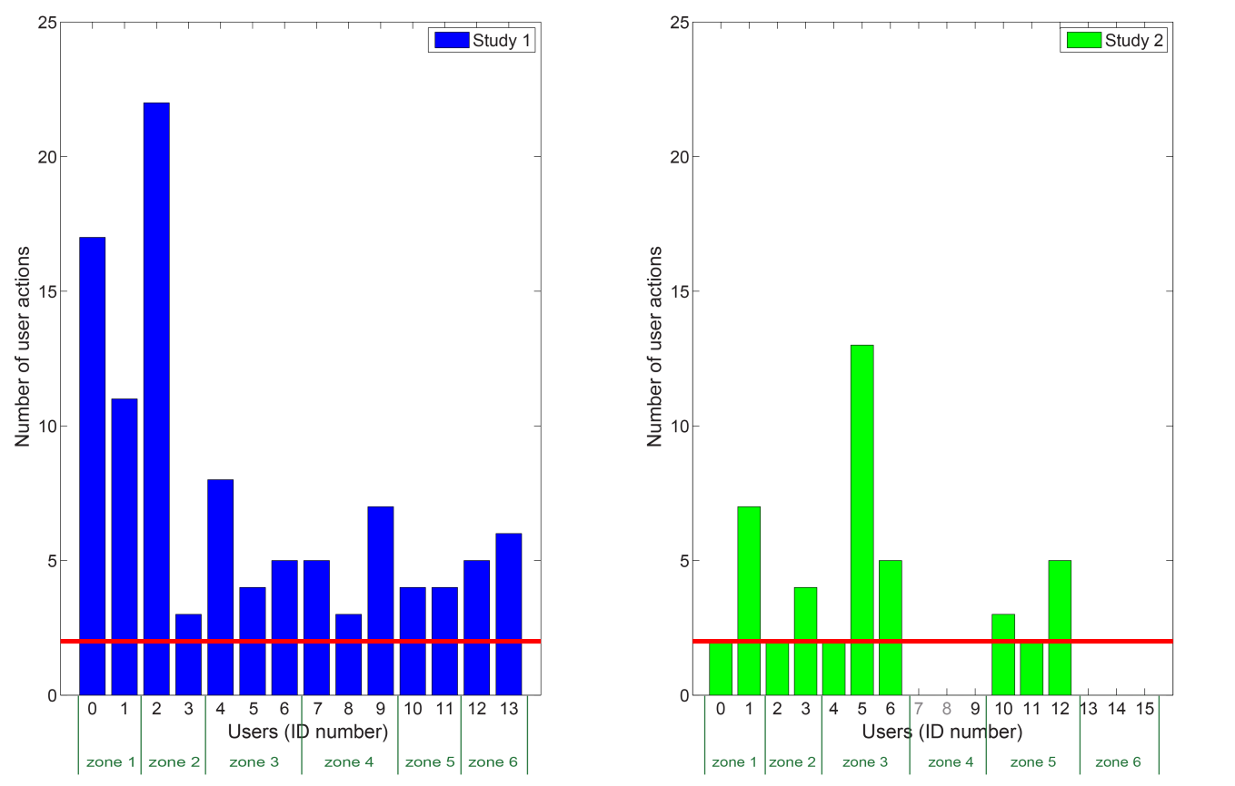

Figure 4. Number of users’ control actions in *study 1* (left) and *study 2* (right) within the control zones. Discrimination line for classification of users on *inactive* and *active* is presented by a solid red line.

As shown in Figure 4, the population consisted of 14 active users in *study 1* and 6 active and 8 inactive users in *study 2.* Some users in *study 2* (IDs 7, 8, 9, 13, 14, and 15) did not perform any control action in the study periods included in this analysis. Users with ID 7 and 8 did not participate in the experiment, but were provided with a device for light control, as mentioned in Section 2.4. Hence, their input is not taken into account in the analysis.

## Tolerance

For classifications of users regarding their level of tolerance, the standard deviation of the selected dimming level is used. It is assumed that offering an illuminance level far from a user’s preferred level would decrease the satisfaction of this user. A standard deviation as a measure of tolerance shows how broad is the range of illuminance levels that a user accepts without initiating a change. A tolerant user will accept a broad range of selected illuminance levels meaning that he will perform his work under a larger variety of lighting conditions, without taking action to adjust them. An intolerant user will demonstrate more consistent choices of preferred illuminance levels resulting in a narrow range [31].

### Clustering

The number of categories of tolerance needs to be derived by *K-*means clustering, since it is unknown a priori. Taking the data of *study 1* and *study 2,* based on the silhouette criterionthe best result is obtained for 2 clusters. The silhouette values of each data point in both clusters are presented in Figure 5.

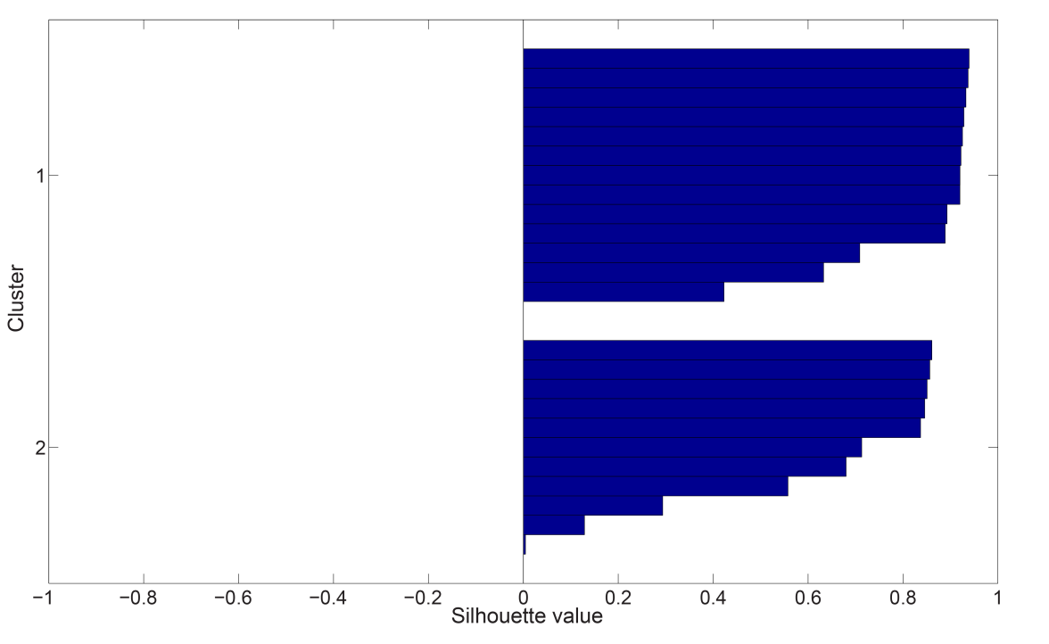

Figure 5. The silhouette values of each data point in both clusters.

As can be seen in Figure 5, only 2 data points among the available 24, have the silhouette values around 0 indicating that they are prone to overlapping. Since most of the data points have high silhouette values, clustering into the two given clusters is found appropriate.

The result of the *K*-means clustering algorithm is presented in Figure 6 with boxplots showing an *intolerant* and a *tolerant* cluster. Crosses represent the centres of each cluster. The discrimination line represents the value of standard deviation for discriminating between two classes of users.

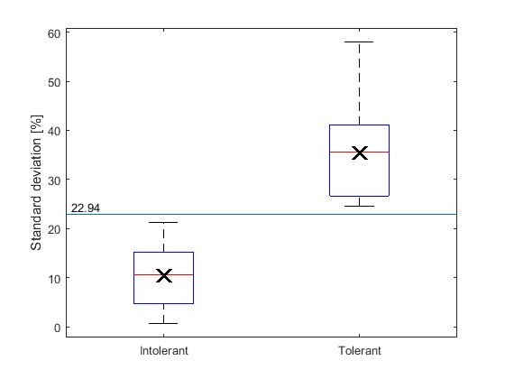

Figure 6. The result of *K*-means clustering algorithm based on standard deviation of users’ control actions with *intolerant* and *tolerant* clusters.

### Classification

The tolerance level of the users of *study 1* and *study 2* is shown in Figure 7. As it can be seen from Figure 6, a threshold of 23% is used. A standard deviation below 23%, classifies the user as *intolerant*, while a standard deviation above 23% classifies the user as *tolerant*.

In *study 1*, there were 7 intolerant and 7 tolerant users, while in *study 2,* 6 intolerant and 4 tolerant users were observed. The remaining 4 participants of *study 2* did not provide any control input to derive their tolerance level.

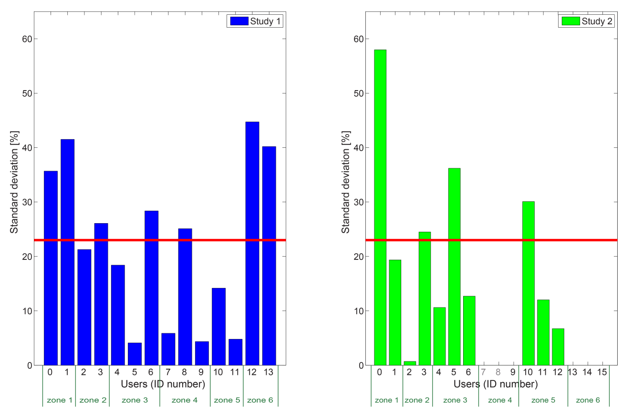

Figure 7. Tolerance level of each of the users based on standard deviation of user’s control actions in *study 1* (left) and *study 2* (right). Control actions were in range from 0-100% and 1-100% of the maximum luminaire output, in *study1* and *study 2*, respectively. The red line represents the discrimination line between *tolerant* and *intolerant* users.

## Dominance

The dominance of a user is relative to the other users in that zone. The dominance can be determined by the fraction of time the luminaire output matched the dimming level set by each user. If the user is dominant, the output level of the luminaire in the user’s control zone will be set in accordance to the user’s preference for most of the time. A more submissive user would hesitate to change the illuminance level.

### Classification

The threshold for discrimination between dominant and submissive users was chosen as

(2)

where represents the number of users within a control zone, e.g. for a zone with 3 users the would be. When the user’s set lighting prevails in his control zone, the user is classified as dominant. For a submissive user his set lighting will remain unchanged for a relative time below the threshold (Table 2).

Table 2. Classification of dominant and submissive users.

|  |  |
| --- | --- |
| User type | Fraction of time |
| Dominant |  |
| Submissive |  |

Figure 8 represents the relative time the output of the zone luminaires had a dimming level set by each user in *study 1* and *study 2*. Based on this classification, the population in *study 1* consisted of 6 dominant and 8 submissive users, and in *study 2* of 5 dominant and 9 submissive users among 14 participants. Users with IDs 9, 13, 14 and 15 did not provide any input during the study and therefore, it is assumed that they were equally submissive.

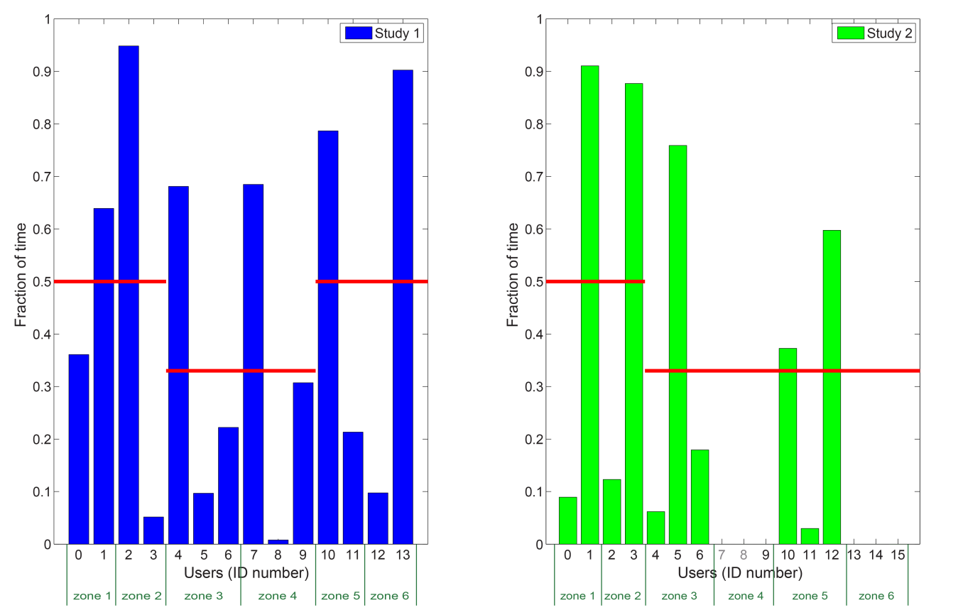

Figure 8. Fraction of time the output of the luminaire had a dimming level set by a certain user in *study 1* (left) and *study 2* (right) in a corresponding control zone.

## Preference

For the preference analysis the authors assume that users select illuminance levels that they find comfortable, and most satisfying. Each user’s preference is calculated as a mean value of the user’s selected dimming levels directly resulting from this particular user’s control actions. The user selected dimming levels are used as input for the preference of a user, regardless of the time the set dimming level prevailed in the zone. A group action as a result of an agreement between multiple users is only used as input to determine the preference of the user who performed the action.

### Clustering

Since the number of user preference classes is unknown, again the *K*-means clustering algorithm is applied to determine the preference clusters (see Section 2.5). Analysing the combined dataset of *study 1* and *study* 2 data, the best clustering results based on the silhouette criterion are obtained for 3 clusters and the silhouette values of each data point are presented in Figure 9. Only 1 data point has a silhouette value close to 0 and is prone to overlapping. The predominating high silhouette values for remaining data points indicate that clustering into 3 clusters is found appropriate.

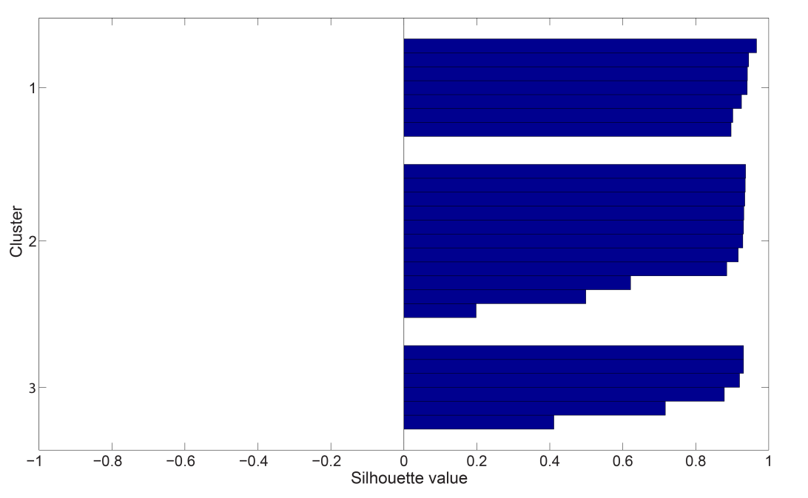

Figure 9. The silhouette values of each data point for 3 clusters.

The result of *K*-means clustering algorithm is shown in Figure 10. Based on the mean values of users’ selected dimming levels obtained by clustering algorithm, the users are categorized as *dark, medium* and *bright*.

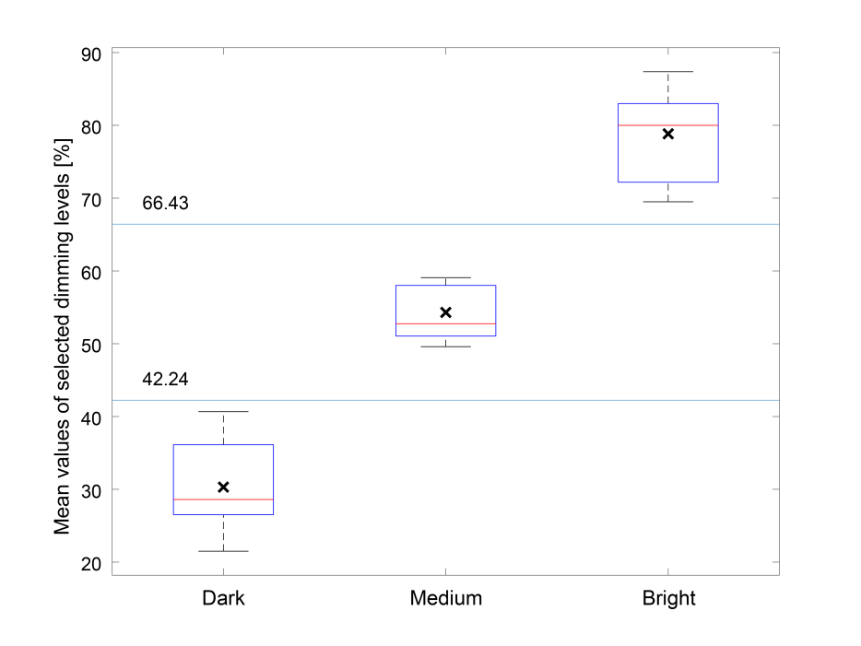

Figure 10. The result of *K*-means clustering algorithm based on mean value of users’ selected dimming levels with *dark, medium* and *bright* clusters.

### Classification

Figure 10 shows the discrimination lines between classes of users calculated as the average distances between the centres of clusters. Table 3 presents the classification approach.

Table 3. Classification of *dark*, *medium* and *bright* users.

|  |  |
| --- | --- |
| User type | Mean value of user’s selected dimming levels [%] |
| Dark |  |
| Medium |  |
| Bright |  |

The classification of users based on the mean value of their selected dimming levels in *study 1* and *study 2* is presented in Figure 11. In *study 1*, the number of dark, medium and bright users is 7, 3, and 4 respectively. In *study 2*, 4 users are classified as dark, 4 as medium and 2 as bright. 4 of the users in *study 2* cannot be classified since they did not perform any control actions during the study period included in this analysis. It can be seen, that user preferences differ largely for users in the same control zone.

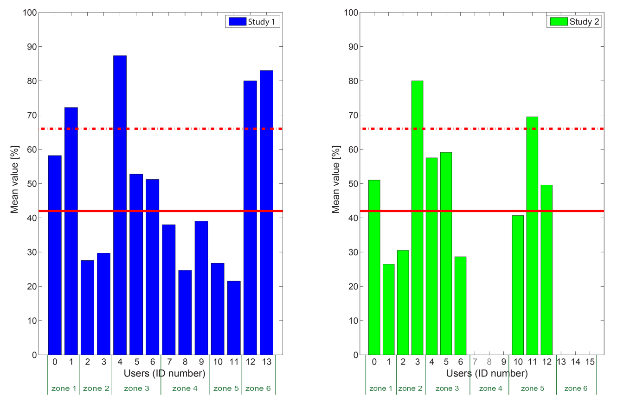

Figure 11. Classification of the users as *dark, medium* or *bright* based on mean values of user’s selected dimming levels in *study 1* (left) and *study 2* (right). The solid red line represents the discrimination line between *dark* and *medium* users (42%), while the dashed red line represents the discrimination line between *medium* and *bright* users (66%).

## Subjective insights

In both studies the participants assessed the frequency by which they had experienced conflict by means of a survey. This evaluation was done at the end of a three weeks period resulting in two evaluations in *study 1* and one in *study* 2 (see Figure 2). Figure 12 shows the results of the mean frequency of experienced conflict in *study 1* and *study 2*, and Figure 13 shows the mean degree of the experienced conflict. As can be seen, in both studies some participants did perceive conflict when controlling lighting. Even though, the degree of the experienced conflict was close to “not at all” for most participants, some participants rated the conflict to be close to “moderate”. In interviews these participants indicated that they preferred a different light setting than their neighbouring colleagues. Depending on their dominance relative to their colleagues, they would either overwrite the lighting to fit their preference, or show conflict avoiding behaviour by not using the light control. Conflict indicated in the survey might not be limited to inter-zone situations. In the interviews of *study 1*, participants of zone 5 and 6 indicated to experience conflicting preferences between the zones.

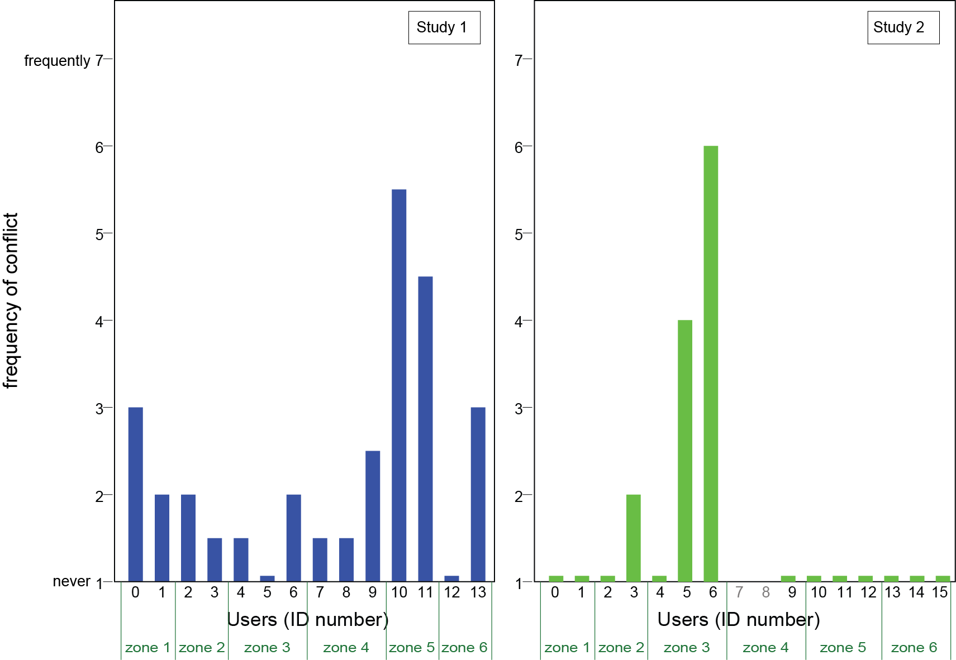

Figure 12. The mean frequency of experienced conflict *study 1* (left) and *study 2* (right).

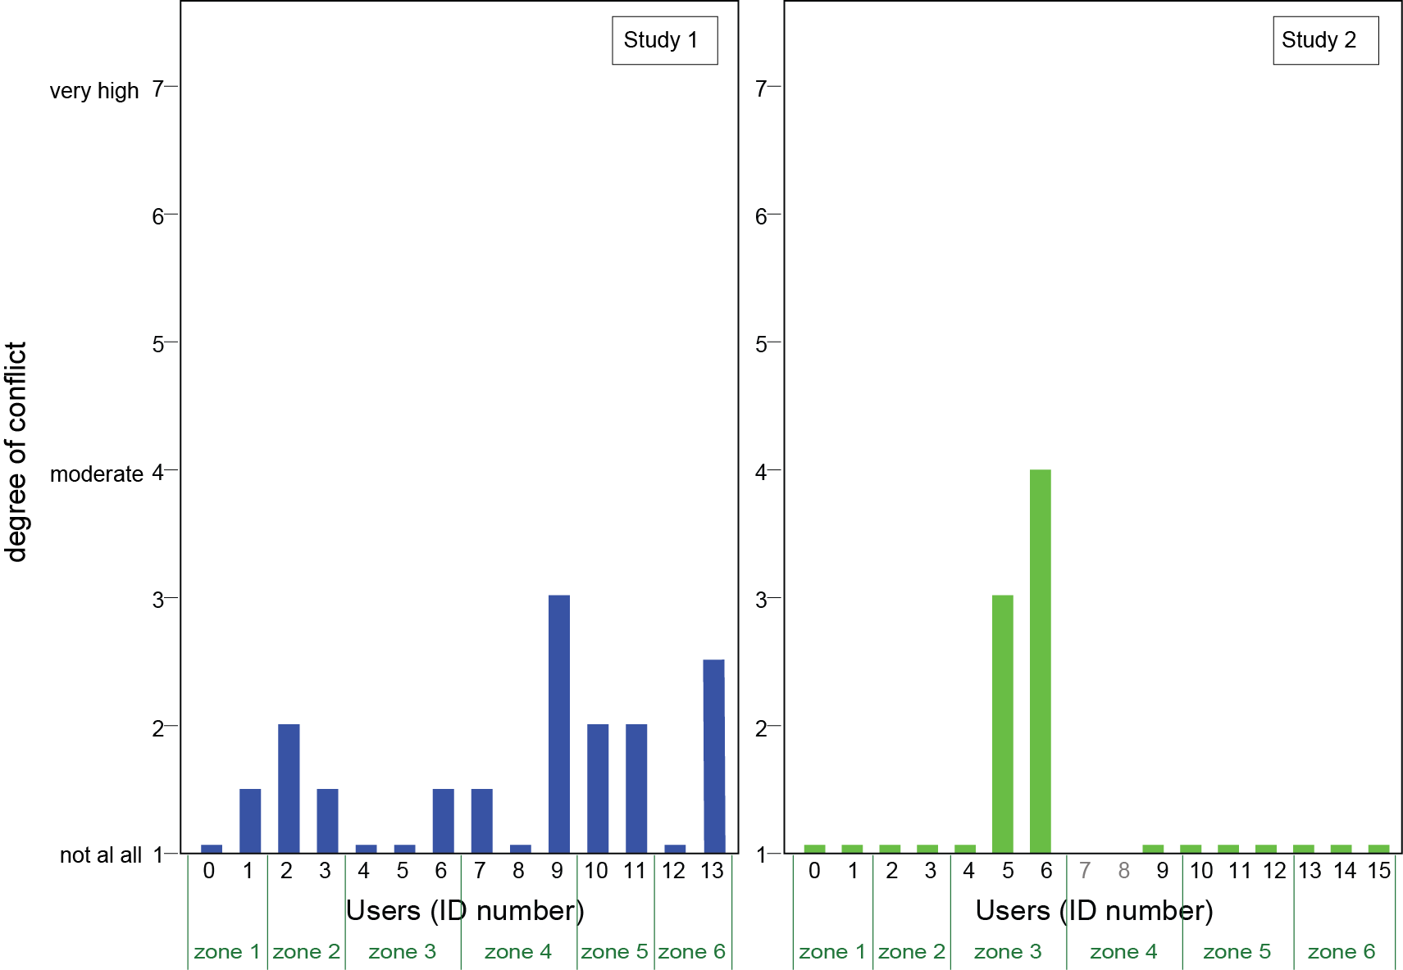

Figure 13. The mean degree of experienced conflict in *study 1* (left) and *study 2* (right)

In the interviews the participants also shared their self-assessed lighting preference. These lighting preferences differed between users in both studies. Results for each user are shown in the overview of Table 4. The labels are self-assessed by the users and do not map to specific illuminance values.

## Control zone classification

The classification of the control zones can be obtained based on lighting preference profiles of the users who occupied them and the zone luminaire output. By knowing how a control zone is classified, the satisfaction of the individual users within a particular zone can be automatically evaluated and conflict between the users can be predicted. By analysing different types of user combinations in the control zones and the actions they performed to set their preferred lighting conditions, we can distinguish 3 cases:

**Case 1:** All users in a control zone are satisfied, the probability of conflict occurring is low.

**Case 2:** User(s) in a control zone are dissatisfied, the probability of conflict occurring is high.

**Case 3:** User(s) satisfaction and the probability of conflict occurring is unknown and therefore, additional input from the user(s) is needed.

A flow chart of control zone classification is given in Figure 14. If all users in the same control zone are active, their profiles can be derived from the control actions they performed, since they provided enough inputs. If users have matching preferences, it can be assumed that users are satisfied and that the probability of occurrence of conflict is low which represents *case 1*. If users have opposing preferences, but all of them are tolerant, there would be a large overlapping between their preferred illuminance levels, which again leads to *case 1*. If more than one user in a control zone is intolerant, meaning that several users are picky regarding the selected illuminance levels, whether conflict would occur depends on whether these users have matching preferences (*case 1*) or not (*case 2*). On contrary, if only one user in a control zone is intolerant, then if this user is also dominant, meaning that his preferred illuminance level is set in a zone for most of the time, he will be satisfied. Since other users in a zone are tolerant, the probability of conflict would be low (*case 1*). On the other hand, if this user is submissive, he will be dissatisfied with lighting conditions due to his pickiness, leading to higher probability of occurrence of conflict (*case 2*). If inactive users are present in a control zone, deriving their profiles is difficult due to lack of inputs from the users. In that case, if the inactive user is dominant, his preference profile can be derived from the zone luminaire output data, since there would be a high correlation between his control choices and the prevailing luminaire output. If an inactive user is submissive, there would be insufficient data for a profile derivation and therefore, additional input from the user is needed in order to obtain that user’s profile as accurately as possible (*case 3*).

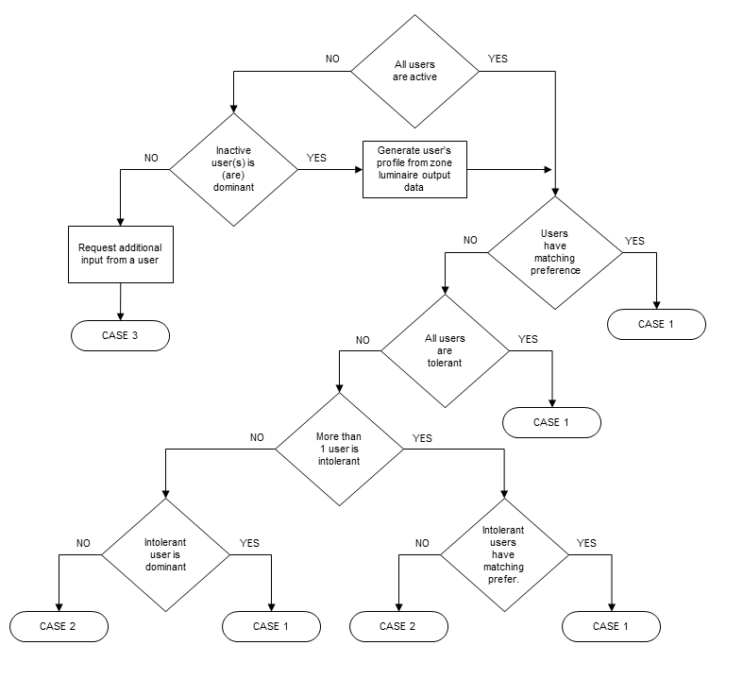

Figure 14. Flowchart of control zone classification.

Based on the analysed data, the summary of the users’ profiles, together with control zone classification is provided in Table 4.

Table 4. Classification of the users and the control zones. ‘*’ symbols represent interpretation of profiles based on the available data. ‘-’ symbols represent the missing data for the users who had no control action during the studies.

|  |  |  |  |  |  |  |  |  |
| --- | --- | --- | --- | --- | --- | --- | --- | --- |
|  |  |  | Objective measurements | | | |  | Subjective measurements |
|  | Zone ID | User ID | Activeness | Tolerance | Dominance | Preference | Zone classification | Preference |
| Study 1 | Zone 1 | 0 | Active | Tolerant | Submissive | Medium | Case 1 | Medium |
| 1 | Active | Tolerant | Dominant | Bright | Bright |
| Zone 2 | 2 | Active | Intolerant | Dominant | Dark | Case 1 | Dark |
| 3 | Active | Tolerant | Submissive | Dark | Dark |
| Zone 3 | 4 | Active | Intolerant | Dominant | Bright | Case 2 | Bright |
| 5 | Active | Intolerant | Submissive | Medium | Bright |
| 6 | Active | Tolerant | Submissive | Medium | Bright |
| Zone 4 | 7 | Active | Intolerant | Dominant | Dark | Case 1 | Dark |
| 8 | Active | Tolerant | Submissive | Dark | Medium |
| 9 | Active | Intolerant | Submissive | Dark | Medium |
| Zone 5 | 10 | Active | Intolerant | Dominant | Dark | Case 1 | Dark |
| 11 | Active | Intolerant | Submissive | Dark | Dark |
| Zone 6 | 12 | Active | Tolerant | Submissive | Bright | Case 1 | Bright |
| 13 | Active | Tolerant | Dominant | Bright | Bright |
| Study 2 | Zone 1 | 0 | Inactive | Tolerant* | Submissive | Medium* | Case 3 | Medium |
| 1 | Active | Intolerant | Dominant | Dark | Dark |
| Zone 2 | 2 | Inactive | Intolerant* | Submissive | Dark* | Case 3 | Medium |
| 3 | Active | Tolerant | Dominant | Bright | Bright |
| Zone 3 | 4 | Inactive | Intolerant* | Submissive | Medium* | Case 3 | Medium |
| 5 | Active | Tolerant | Dominant | Medium | Bright |
| 6 | Active | Intolerant | Submissive | Dark | Dark |
| Zone 4 | 7 | Inactive | - | Submissive | - | Case 3 | - |
| 8 | Inactive | - | Submissive | - | - |
| 9 | Inactive | - | Submissive | - | Medium |
| Zone 5 | 10 | Active | Tolerant | Dominant | Dark | Case 3 | Medium |
| 11 | Inactive | Intolerant* | Submissive | Bright* | Medium |
| 12 | Active | Intolerant | Dominant | Medium | Medium |
| Zone 6 | 13 | Inactive | - | Submissive | - | Case 3 | Medium |
| 14 | Inactive | - | Submissive | - | Dark |
| 15 | Inactive | - | Submissive | - | Bright |

### Overcoming the limitation of low number of data points

In both studies, the number of data points was generally low. There is a number of potential reasons. The user-control conditions in both studies were commissioned with “memorizing” system behaviour. Starting from a default light setting with a desk illuminance of 300 lx, the luminaires within the control group stayed at the previously set dimming level until the next control action was performed. Due to this system behaviour, is it likely that users regarded it as unnecessary to perform further actions after they had set the lighting according to their preference. As also illustrated in Figure 12 and Figure 13, the frequency and degree of conflict was very low for most users. However, some users did experience conflict. The submissive users confirmed in the interviews that applied conflict avoiding behaviour and felt a hesitation to change lighting even when they were dissatisfied. In *study 2,* 4 users did not perform any control action during investigated periods. This might occur due to users’ conflict avoiding behaviour, or due to a broad tolerance of the users. Information about user’s satisfaction with lighting conditions would facilitate the classification of submissive users, since their submissiveness suppresses accurate classification of their preference profiles. Hence, all control zones in *study 2* are classified as *case 3* (see Table 4).

When *case 3* is detected, additional input would be required to derive the user’s lighting preference profile. Figure 15 presents the proposed flowchart to gain this information from the user. The first input is related to the user’s satisfaction with lighting conditions. If a user is inactive, but satisfied, it means that lighting conditions are in accordance to user’s preference, i.e., the probability of occurrence of conflict will be low (*case 1*). In that case, a user’s profile can be generated based on the zone luminaire output data; there is no need for further input. If a user is inactive, but dissatisfied, additional input of preferred lighting would be required. This could be done by a push message requesting the user to set the lighting, or by asking the user to evaluate the existing lighting condition. By means of such requests, the profile of the submissive users can be determined.

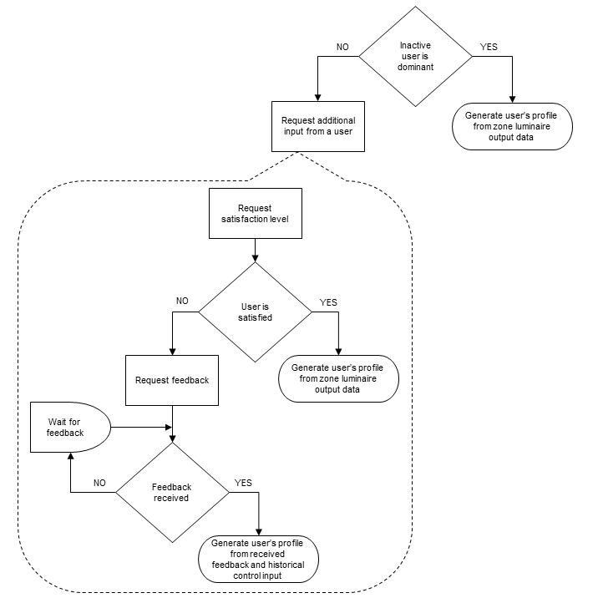

Figure 15. Flowchart of request for additional input from user and derivation of user’s lighting preference profile based on user’s feedback.

To support the benefits of proposed approach for deriving the preference profiles of inactive users, survey input regarding users’ evaluation of the light quantity on their desk is used. When an inactive user is classified as dominant or is satisfied with lighting conditions, the user’s profile can be generated from the zone luminaire output data (see Figure 15). Based on the additional input from user’s satisfaction, and when applicable, zone luminaire output, profiles of the inactive users are updated and presented as *italic* in Table 5. Note that only quantitative data of inactive users is evaluated, since active users are assumed to provide enough input and that, therefore, their satisfaction and possible conflict within their zones, can be evaluated automatically.

Table 5. Updated classification of the users and the control zones based on satisfaction data. ‘*’ symbols represent interpretation of profiles based on the perceived light quantity and satisfaction

|  |  |  |  |  |  |  |  |  |  |
| --- | --- | --- | --- | --- | --- | --- | --- | --- | --- |
|  |  |  | Quantitative measurements | | Objective measurements | | | |  |
|  | Zone ID | User ID | Satisfaction | Perceived light quantity | Activeness | Tolerance | Dominance | Preference | Zone classification |
| Study 2 | Zone 1 | 0 | Somewhat dissatisfied | A bit too little | Inactive | - | Submissive | *Medium\** | *Case 2\** |
| 1 | - | - | Active | Intolerant | Dominant | Dark |
| Zone 2 | 2 | Satisfied | Just right | Inactive | *Tolerant* | Submissive | *Medium* | *Case 1* |
| 3 | - | - | Active | Tolerant | Dominant | Bright |
| Zone 3 | 4 | Satisfied | Just right | Inactive | *Tolerant* | Submissive | *Medium* | *Case 2* |
| 5 | - | - | Active | Tolerant | Dominant | Medium |
| 6 | - | - | Active | Intolerant | Submissive | Dark |
| Zone 4 | 7 | - | - | Inactive | - | Submissive | - | *Case 1* |
| 8 | - | - | Inactive | - | Submissive | - |
| 9 | Satisfied | Just right | Inactive | *Intolerant* | Submissive | *Dark* |
| Zone 5 | 10 | - | - | Inactive | Intolerant | Dominant | Medium | *Case 1* |
| 11 | Satisfied | Just right | Inactive | *Intolerant* | Submissive | *Medium* |
| 12 | - | - | Inactive | Intolerant | Dominant | Medium |
| Zone 6 | 13 | Satisfied | Just right | Inactive | *Intolerant* | Submissive | *Medium* | *Case 2\** |
| 14 | Somewhat dissatisfied | A bit too much | Inactive | - | Submissive | *Dark\** |
| 15 | Somewhat dissatisfied | A bit too little | Inactive | - | Submissive | *Bright\** |

As it can be seen, the satisfaction with lighting conditions represents valuable information when profiles of inactive users need to be derived. Preference of users with ID 0, 14 and 15 are interpreted based on the perceived light quantity and their satisfaction. Users with ID 0 and 14 rated their perceived light quantity towards ‘*too dark*’. In case of zone 1, predominating dimming level in the zone was in dark range, while in zone 6, it was medium. Therefore, the preference of users with ID 0 and 15 are labelled as medium and bright, respectively. Similarly, user with ID 14, rated the perceived light quantity towards ‘*too bright*’ and his preference is labelled as dark, since predominating dimming level in his zone was in medium range. These users represent the clear case of submissiveness and conflict avoiding behaviour which was confirmed in the interviews. For profile derivation of these users, additional input in terms of preferred lighting is required as presented in Figure 15.

# Discussion

## Population size

To be able to classify users according to their activeness, tolerance and preference, the data related to the whole population of users (n = 28) was used. These classes represent general categories invariant to the analysed study. Analyses related to the users’ tolerance levels and preferred illuminance levels are based on a population of 24 users from both studies, since in *study 2*, 4 users did not perform a single control action during the analysed periods, and a classification of those cases could not be done. The dominance of a user is classified relative to the other users in that zone (n = 2-3), since the characteristic is relative to the dominance of the specific users with whom the zone is shared. Therefore, it cannot be analysed based on the whole population of users who participated in the studies.

## Classification thresholds

The values of classification thresholds are derived based on the data obtained in these specific studies and could have different values for a different population of users. However, this paper presents a general approach for clustering and classification that could be applied to any population of users. Obtaining the classification threshold in case of dominance as explained in Section 3.3.1 is invariant to the data used.

## Objective versus subjective preference labels

Table 4 presents the subjective self-assessed preference labels of the users, as well as the labels derived from the objective measurements. The self-assessed labels, obtained in the interviews, deviate in some cases from the labels derived from the objective measurements. The preference labels are based on calculated thresholds using the objective measurements. On the contrary, users do not categorize themselves using similar thresholds, but have their own way to describe their preference. The self-assessed categories were often based on personal experiences when performing visual tasks. The majority of the cases do show a match, which suggests that users do possess self-knowledge of their lighting preference, when classifying it in the presented three categories. Some users did describe their light preference in the interviews, but did not perform any control actions in the analysed period. Their preference description might be based on the experienced lighting condition during the study, but might also be based on these users’ previous experiences.

In Section 3.4 it is shown that the best clustering results based on users’ preferred dimming levels are obtained for 3 clusters. As it can be seen from Table 4, the self-assessed preference labels matched the same number of categories i.e. *dark, medium* and *bright*.

By taking the information about perceived light quantity and satisfaction with lighting conditions into account, a better match between self-assessed and derived preference labels is found (see Table 4 and Table 5). This confirms that these inputs represent valuable information when profiles of inactive users cannot be derived purely based on their control behaviour. Furthermore, validity of the approach presented in Figure 15 is verified.

## Experienced conflict

In the presented analyses it is assumed that conflict has the highest probability within the user’s control zone. By measurements of the desk illuminances in the office, it is confirmed that the zone lighting has a sizeable influence on the desks within the zone beyond daylight. However, this does not exclude the possibility that conflict might occur in the user’s visual field beyond his own control zone.

Based on Figure 12 and Figure 13, users with ID 5 and 6 in zone 3 in *study 2*, experienced moderate level of conflict quite frequently, which is confirmed by zone classification (see Table 5). However, users with ID 10, 11 and 13, in *study 1*, located in the zones 5 and 6, respectively, also experienced conflict, which is not seen in the classification results. In the interviews, users confirmed that have matching preferences with the neighbours in their own zones, but opposing preferences with users in the adjacent zone as presented in Section 3.5. The analysis of the conflict between zones is out of scope of this paper and it will be addressed in the future work.

## Limitations and possible improvements

In these studies, individual presence information of users was not available. Lighting was controlled based on overall occupancy of the office space, as explained in Section 2.1. Therefore, it was not possible to determine what each user actually experienced during the study, regarding lighting conditions. Having the presence information would help to generate the preference labels more accurately and to better distinguish between user’s preference and acceptance. An illuminance level set by a particular user is clearly recognizable as his preference. If a user experiences an illuminance level set by his zone neighbours, the presence of his colleagues influences the interpretation of this data. If a user is alone in a control zone, without any social obstacles to change lighting, the illuminance level of the zone represents the user’s preference, regardless of the action holder. If a user is not alone, the prevailing illuminance level represents the user’s acceptance, but might not be his preference. Distinguishing between acceptance and preference helps to recognize submissive users. If lighting conditions that user accepts differ from this user’s preference, this is an indication of submissiveness.

Another problem that might arise from lack of individual presence information is that a group action as a result of an agreement between multiple users would be used as input to determine the preference of the user who performed the action. Without individual presence information, this action with be identified as a preferred choice of that user.

In this paper, preference labels are derived based only on user’s lighting control actions and luminaire output data, and are independent from contextual and environmental data. Using this method, preference profiles could be determined without additional sensorial data. However, people could have different preference depending on e.g. the time of the day, weather conditions and presence of colleagues in the control zone or office space. Besides, when a user, for example, selects dimming levels in the ‘dark’ range, it might be that he does not prefer dark lighting conditions, but he compensates for high room brightness due to high wall luminance. Further elaboration on environmental factors that might influence user’s lighting preference is part of work in progress and will be published separately.

In this paper the activeness is determined based on a proposed threshold of 2 actions per user. It is arguable whether reliable classification needs more data points. Additional evaluation is needed to assess the error in profiling based on this limited number of actions. However, with a higher threshold for activeness, the proposed method stays identical, only more users might be asked for additional satisfaction data, resulting in more reliable classification.

It can be observed that profiles of the users significantly differ from each other even for users in the same control zone that experienced similar environmental conditions. This is a clear indication that satisfactory lighting conditions cannot be obtained by providing a fixed illuminance level for all users and that we need to take users’ profiles into account when offering lighting. By knowing the profiles of the users in the space, the satisfaction can be increased by automatically considering their personal as well as preferences of their neighbours.

# Conclusion

This paper proposes a method for modelling lighting preference profiles of users based on their control behaviour and preference information to offer satisfying lighting to a group of users. The results showed that there are differences between lighting preference profiles of users and these profiles could be derived from user control actions data and luminaire output data. Differences in profiles need to be taken into account when offering lighting conditions in open space environments.

It has been shown that users can be profiled based on their activeness, tolerance, dominance and lighting preferences. By knowing lighting preference profiles of the users and zone classification, satisfaction of the users with the lighting conditions can be improved by

* Predicting the probability of conflict between the users in the same control zone and facilitate in making consensus choices.
* Offering lighting conditions that meet the preference profiles of the users. A proposed illuminance level could result from a weighted combination of user profiles and by taking into account whether users in the same zone are tolerant or intolerant. A tolerant user can be satisfied with a broad range of illuminance levels and therefore, the weighting needs to be done by shifting a proposed illuminance level towards a preference of an intolerant, pickier user.
* Triggering a submissive user to express their preferences. A submissive user will represent an inactive user, whose choices are not correlated with the prevailing luminaire output in his zone. This situation might lead to increased discomfort of this particular user. In that case, additional user input is required in order to derive his lighting preference profile as accurate as possible (see Figure 15).

A semi-automatic system which proposes lighting automatically by using the lighting preference profiles can support users in finding consensus in addition to the benefits of manual personal control. In this paper it has been assumed that lighting preference of a user can be derived based on user’s control actions only. Further elaboration on environmental factors influencing user’s preference is a subject of work in progress. In that case, the prediction of users’ control actions in terms of offering satisfactory lighting conditions can be performed based on the contextual data collected in the office.

# Acknowledgements

This research was performed within the framework of the strategic joint research program on Intelligent Lighting between TU/e and Philips Lighting B.V. and it was kindly supported by the Netherlands Organisation for Scientific Research (NWO) project EnSO, contract no. 647.000.004. We like to thank prof. dr. Bert de Vries from Eindhoven University of Technology who provided insights and expertise that greatly assisted the research.

# References

|  |  |
| --- | --- |
| [1] | Gensler, "2013 U.S. Workplace Survey - Key Findings," Springer London, London, 2013. |
| [2] | Knoll, "Shaping the dynamic workplace," 2011. |
| [3] | European committee for standardization, *EN 12464-1:2011 Light and lighting - Lighting of work places - Part 1: Indoor work places,* 2011. |
| [4] | Illuminating Engineering Society, Lighting Handbook 10th Edition, 2011. |
| [5] | J. Veitch and G. Newsham, "Preferred luminous conditions in open-plan offices: research and practice recommendations," *Lighting Research and Technology,* vol. 32, no. 4, pp. 199-212, 2000. |
| [6] | G. Newsham, J. Veitch and C. Arsenault, "Effect of dimming control on office worker satisfaction and performance," in *Proceedings of the IESNA annual conference*, Tampa FL, New York, 2004. |
| [7] | P. Boyce, N. Eklund and S. Simpson, "Individual lighting control: task performance, mood, and illuminance," *Journal of Illuminating Engineering Society,* vol. 29, pp. 131-142, 2000. |
| [8] | P. Boyce, A. Veitch, R. Newsham, C. Jones, J. Heerwagen, M. Myer and C. Hunter, "Occupant use of switching and dimming controls in offices," *Lighting Research and Technology,* vol. 38, no. 4, pp. 358-378, 2006. |
| [9] | T. Moore, D. Carter and A. Slater, "Long-term patterns of use of occupant controlled office lighting," *Lighting Research and Technology,* vol. 35, no. 1, pp. 43-59, 2003. |
| [10] | J. A. Veitch, K. E. Charles, G. R. Newsham, C. J. G. Marquardt and J. Geerts, "Environmental satisfaction in open-plan environments: 5. Workstation and physical condition effects," NRC/IRC Research Report RR-154, National Research Council Canada, Institute for Research in Construction, Ottawa, ON, 2003. |
| [11] | J. A. Veitch, J. Geerts, K. E. Charles, G. Newsham and C. Marquardt, "Satisfaction with lighting in open-plan offices: COPE field findings," in *Proceedings of Lux Europa* , Berlin, Germany, 2005. |
| [12] | J. A. Veitch, K. E. Charles, K. M. J. Farley and G. R. Newsham, "A model of satisfaction with open-plan office conditions: COPE field findings," *Journal of Environmental Psychology,* vol. 27, pp. 177-189, 2007. |
| [13] | J. Veitch, C. Donnelly, A. Galasiu, G. Newsham, D. Sander and C. Arsenault, "IRC Research Report 299: Office occupants' evaluations of an individually-controllable lighting systems," National Research Council Canada, Institute for Research in Construction, Ottawa, 2010. |
| [14] | P. Boyce, J. A.Veitch, G. Newsham, M. Myer and C. Hunter, "Lighting quality and office work: A field simulation study," Pacific Northwest National Laboratory, Richland, WA, USA,, 2003. |
| [15] | G. Newsham and J. Veitch, "Lighting quality recommendations for VDT offices: a new method of derivation," *Lighting Research and Technology,* vol. 33, no. 2, pp. 115-134, 2001. |
| [16] | S. Y. Lee and J. L. Brand, "Effects of control over office workspace on perceptions of the work environment and work outcomes," *Journal of Environmental Psychology,* vol. 25, pp. 323-333, 2005. |
| [17] | T. Moore, D. Carter and A. Slater, "A study of opinion in offices with and without user controlled lighting," *Lighting Research and Technology,* vol. 36, no. 2, pp. 131-146, 2004. |
| [18] | P. Boyce, J. Veitch, G. Newsham, M. Myer and C. Hunter, "Lighting quality and office work: two field simulation experiments," *Lighting Research and Technology,* vol. 38, no. 3, pp. 191-223, 2006. |
| [19] | J. Veitch, G. Newsham, P. Boyce and C. Jones, "Lighting appraisal, well-being, and performance in open-plan offices: A linked mechanisms approach," *Lighting Research and Technology,* vol. 40, no. 2, pp. 133-151, 2008. |
| [20] | W. O'Brien and H. B. Gunay, "The contextual factors contributing to occupants' adaptive comfort behaviors in offices - A review and proposed modeling framework," *Building and Environment,* vol. 77, pp. 77-87, 2014. |
| [21] | J. C. Vischer, "The effects of the physical environment on job performance: towards a theoretical model of workspace stress," *Strees and Health,* vol. 23, pp. 175-184, 2007. |
| [22] | T. Moore, D. Carter and A. Slater, "A field study of occupant controlled lighting in offices," *Lighting Research and Technology,* vol. 34, no. 3, pp. 191-205, 2002. |
| [23] | S. Chraibi, T. Lashina, P.Shrubsole, M. Aries, E. v. Loenen and A. Rosemann, "Satisfying light conditions: A field study on perception of consensus light in Dutch open office environments," *Building and Environment,* vol. 105, pp. 116-127, 2016. |
| [24] | M. Wright, S. Hill, G. Cook and K. Bright, "The perception of lighting quality in a non-uniformly lit office environment," *Facilities,* vol. 17, pp. 476-484, 1999. |
| [25] | S. Escuyer and M. Fontoynont, "Lighting controls: A field study of office workers' reactions," *Lighting Research and Technology,* vol. 33, no. 2, pp. 77-96, 2001. |
| [26] | C. Reinhart and K. Voss, "Monitoring manual control of electric lights and blinds," *Lighting Research and Technology,* vol. 35, no. 3, pp. 243-260, 2003. |
| [27] | T. Moore, D. Carter and A. Slater, "Conflict and Control: The use of locally addressable lighting in open plan office space," in *Proceedings of the Chartered Institute of Building Services* , 2000. |
| [28] | S. P. Lloyd, "Least squares quantization in PCM," *IEEE Transactions on Information Theory,* vol. 28, no. 2, pp. 129-137, 1982. |
| [29] | C. Bishop, Pattern Recognition and Machine Learning, Springer-Verlag New York, Inc. Secaucus, NJ, USA, 2006. |
| [30] | P. Rousseeuw, "Silhouettes: A graphical aid to the interpretation and validation of cluster analysis," *Journal of computational and applied mathematics,* vol. 20, pp. 53-65, 1987. |
| [31] | V. Singhvi, A. Krause, C. Guestrin, J. H. G. Jr. and H. S. Matthews, "Intelligent light control using sensor networks," in *Proceedings of the 3rd international conference on Embedded networked sensor systems, SenSys*, San Diego, California, USA, 2005. |